Experiment-1
Aim
To read an image using Python and OpenCV and convert the image into a gray-scale image.
Procedure
- Import the OpenCV library.
- Read the input image using cv2.imread().
- Convert the color image into gray-scale using cv2.cvtColor().
- Display the original and gray-scale images.
- Save the gray-scale image if required.
Code
import cv2
img = cv2.imread(r"C:\Users\VARSHINI\Downloads\sample image.jpg")
if img is None:
print("Image not found!")
exit()
gray = cv2.cvtColor(img, cv2.COLOR_BGR2GRAY)
cv2.imshow("Original Image", img)
cv2.imshow("Gray Image", gray)
cv2.waitKey(0)
cv2.destroyAllWindows()
Sample Input
Input: r"C:\Users\VARSHINI\Downloads\sample image.jpg"-a color image.
Sample Output
- Original color image 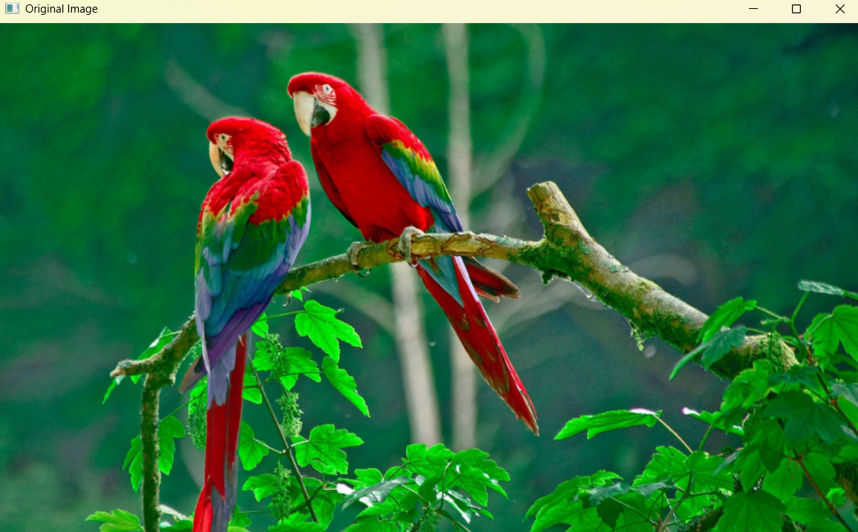
- Gray-scale version of the image
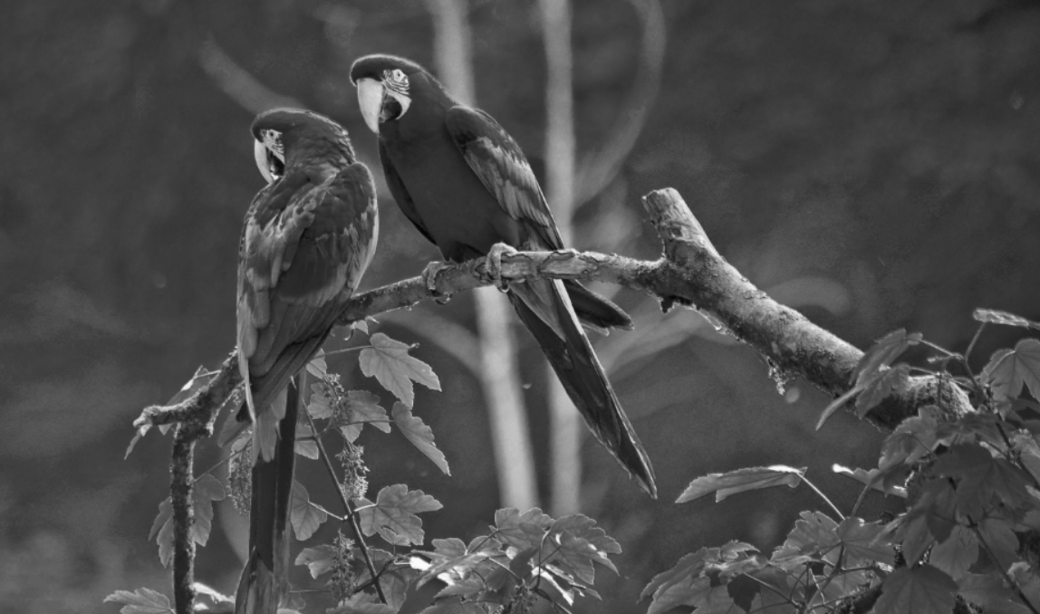
Result
Thus, the given color image was successfully read and converted into a gray-scale image using OpenCV.

